**ADVANCED DATABASE TECHNOLOGY**

**PRACTICE ASSIGNMENT-2 ON UNIT – 5**

Name: Johanan Joshua

Reg. no: 2347119

Class: 1 MCA ‘A’

* Practice CRUD (**CREATE, READ, UPDATE, and DELETE)** operations on MongoDB

CREATE:

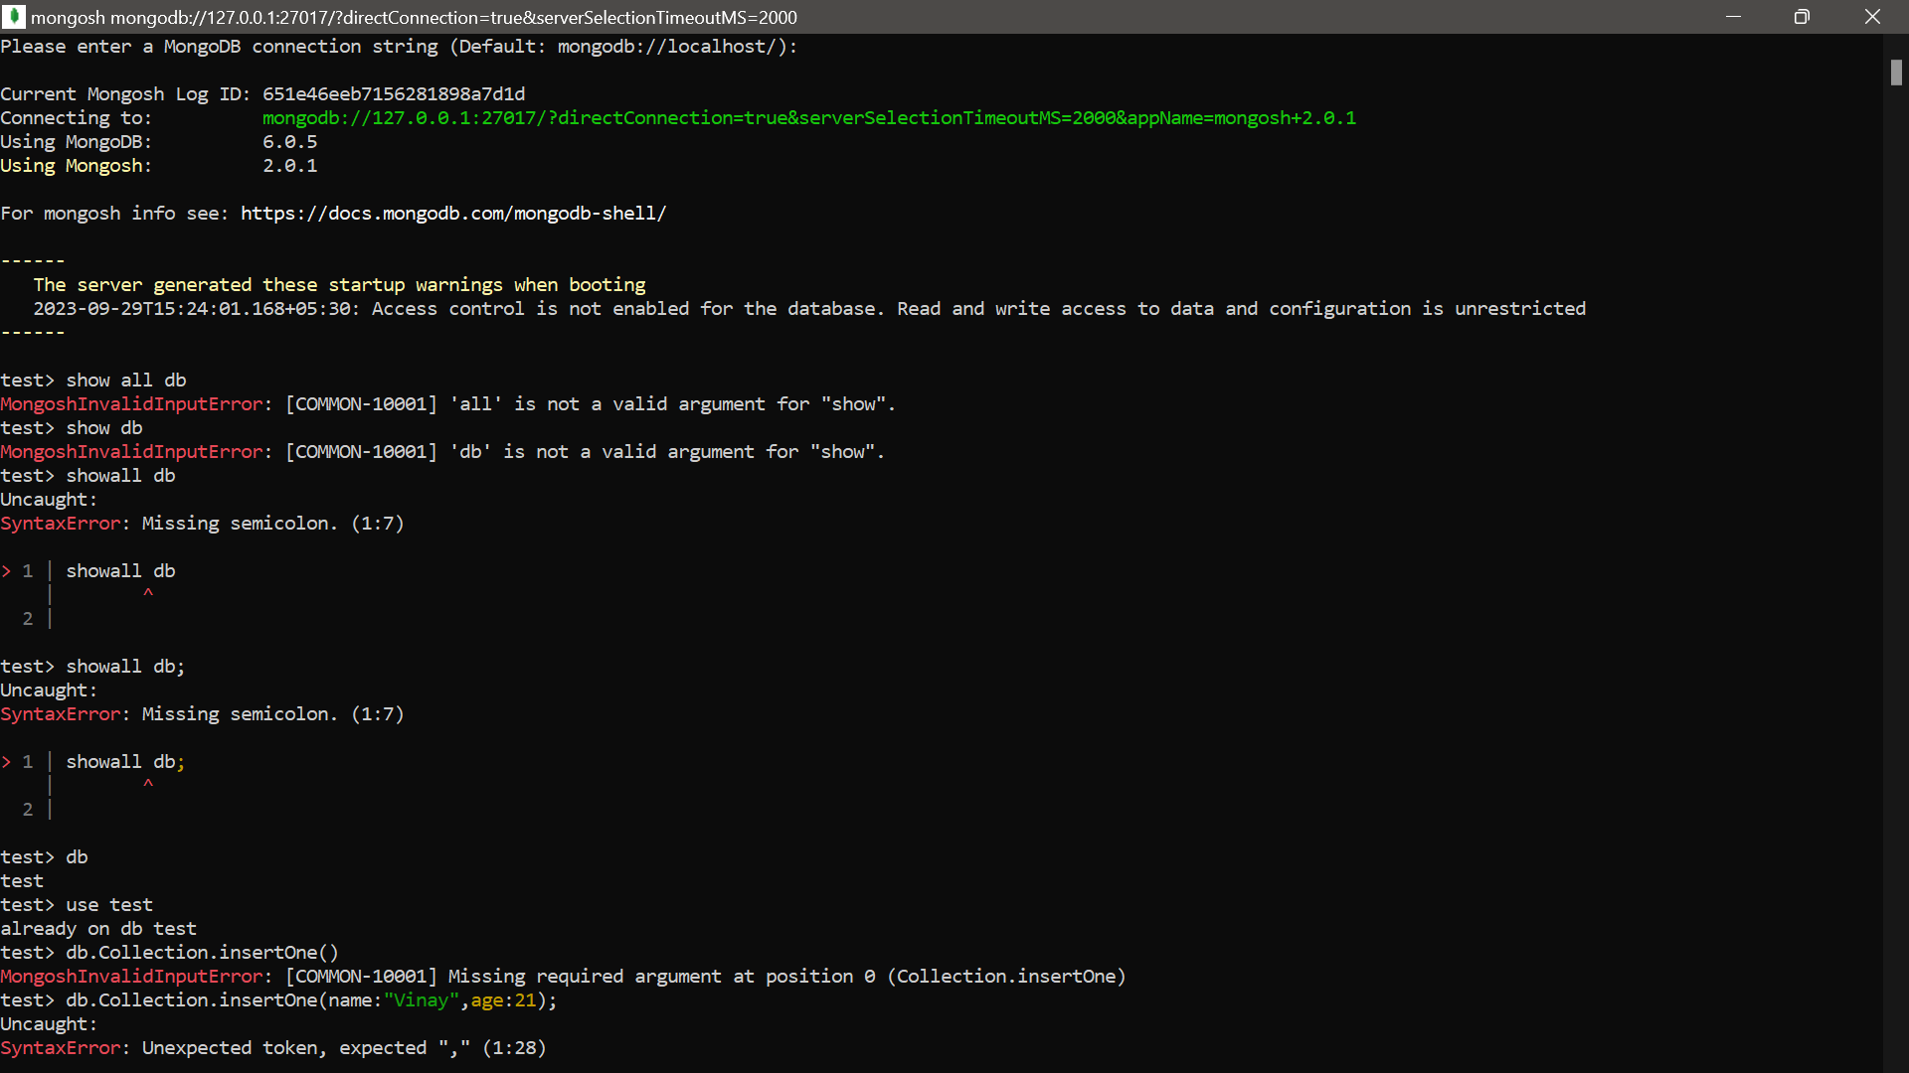

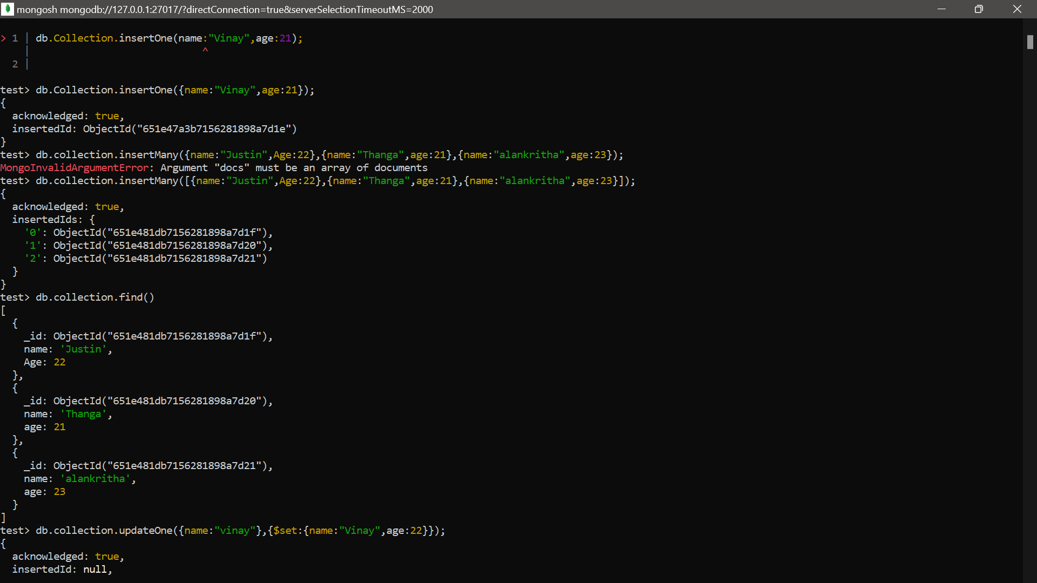

**UPDATE:**

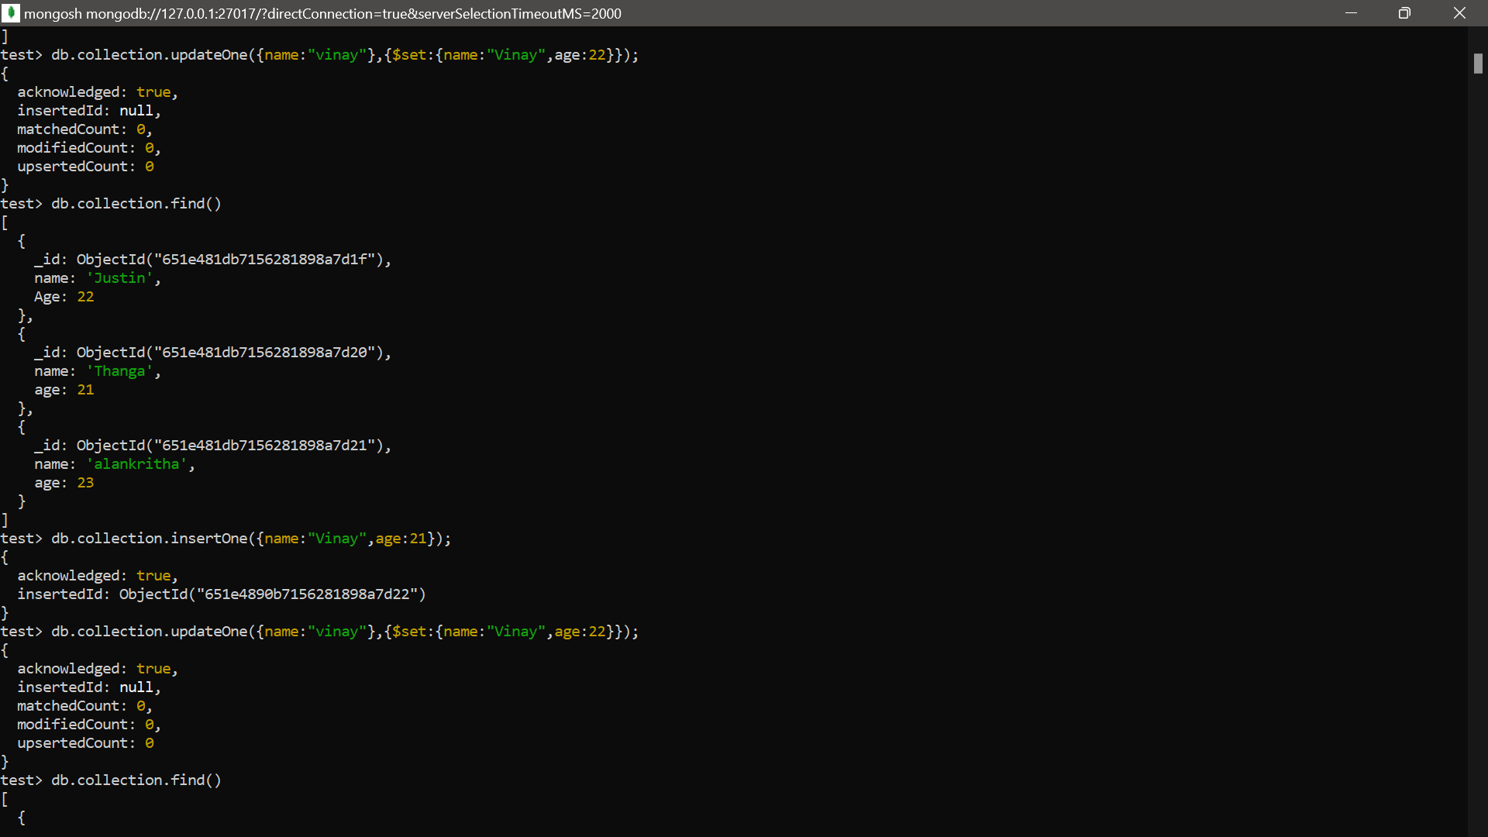

**DELETE:**

